Friday 26th June – ATLAS 2026 buildings and rooms map
James Graham buildingL
The Acre room (breaks)
Lecture theatre B (plenaries)

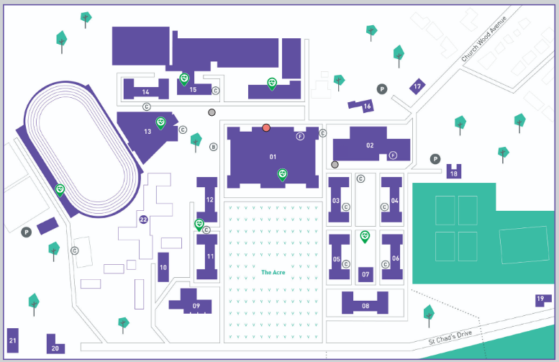
Lunch Boxes Collection:
LBU canteen (Campus Central)
Macaulay building
Priestley building

